Date:17/10/2022

COAL LAB Mid:
Name: Owais Ali Khan
Roll: 21K-3298
Section: 3-F

Question # 01:

TITLE Question 1
INCLUDE Irvine32.inc

.data
var1 SWORD -10d, 20o, -30, 40o, -50, 60h, 80, -90, 100b, 110h, 120o, 130h, 140h, 150o, 160d
var2 SDWORD -80, -456, 98h, -4998, -9817, 9827, 68h, 628h, -7, 8943, 6798h, 1635, 87Ah
var3 SBYTE -85, -64, 47o, -46, 0Ah, 50d, 55, 19h, 20d, 10o
message BYTE "Value of ebx in decimal = ", 0

.code
main PROC
mov ebx, 0
add ebx, var2[1 * TYPE var2]
sub bx, var1[2 * TYPE var1]
sub bx, var1[3 * TYPE var1]
add bl, var3[4 * TYPE var3]
add bx, var1[5 * TYPE var1]
sub bl, var3[6 * TYPE var3]
add ebx, var2[7 * TYPE var2]
call Dumpregs
mov edx, OFFSET message
call WriteString
mov eax, ebx
call WriteInt
call Crlf

mov ebx, 0
add bx, var1[2 * TYPE var1]
add bx, var1[4 * TYPE var1]
sub ebx, var2[6 * TYPE var2]
add bl, var3[6 * TYPE var3]
sub bl, var3[8 * TYPE var3]
add ebx, var2[10 * TYPE var2]
add bx, var1[12 * TYPE var1]
call Dumpregs
mov edx, OFFSET message
call WriteString
mov eax, ebx
call WriteInt
call Crlf

exit
main ENDP
END main
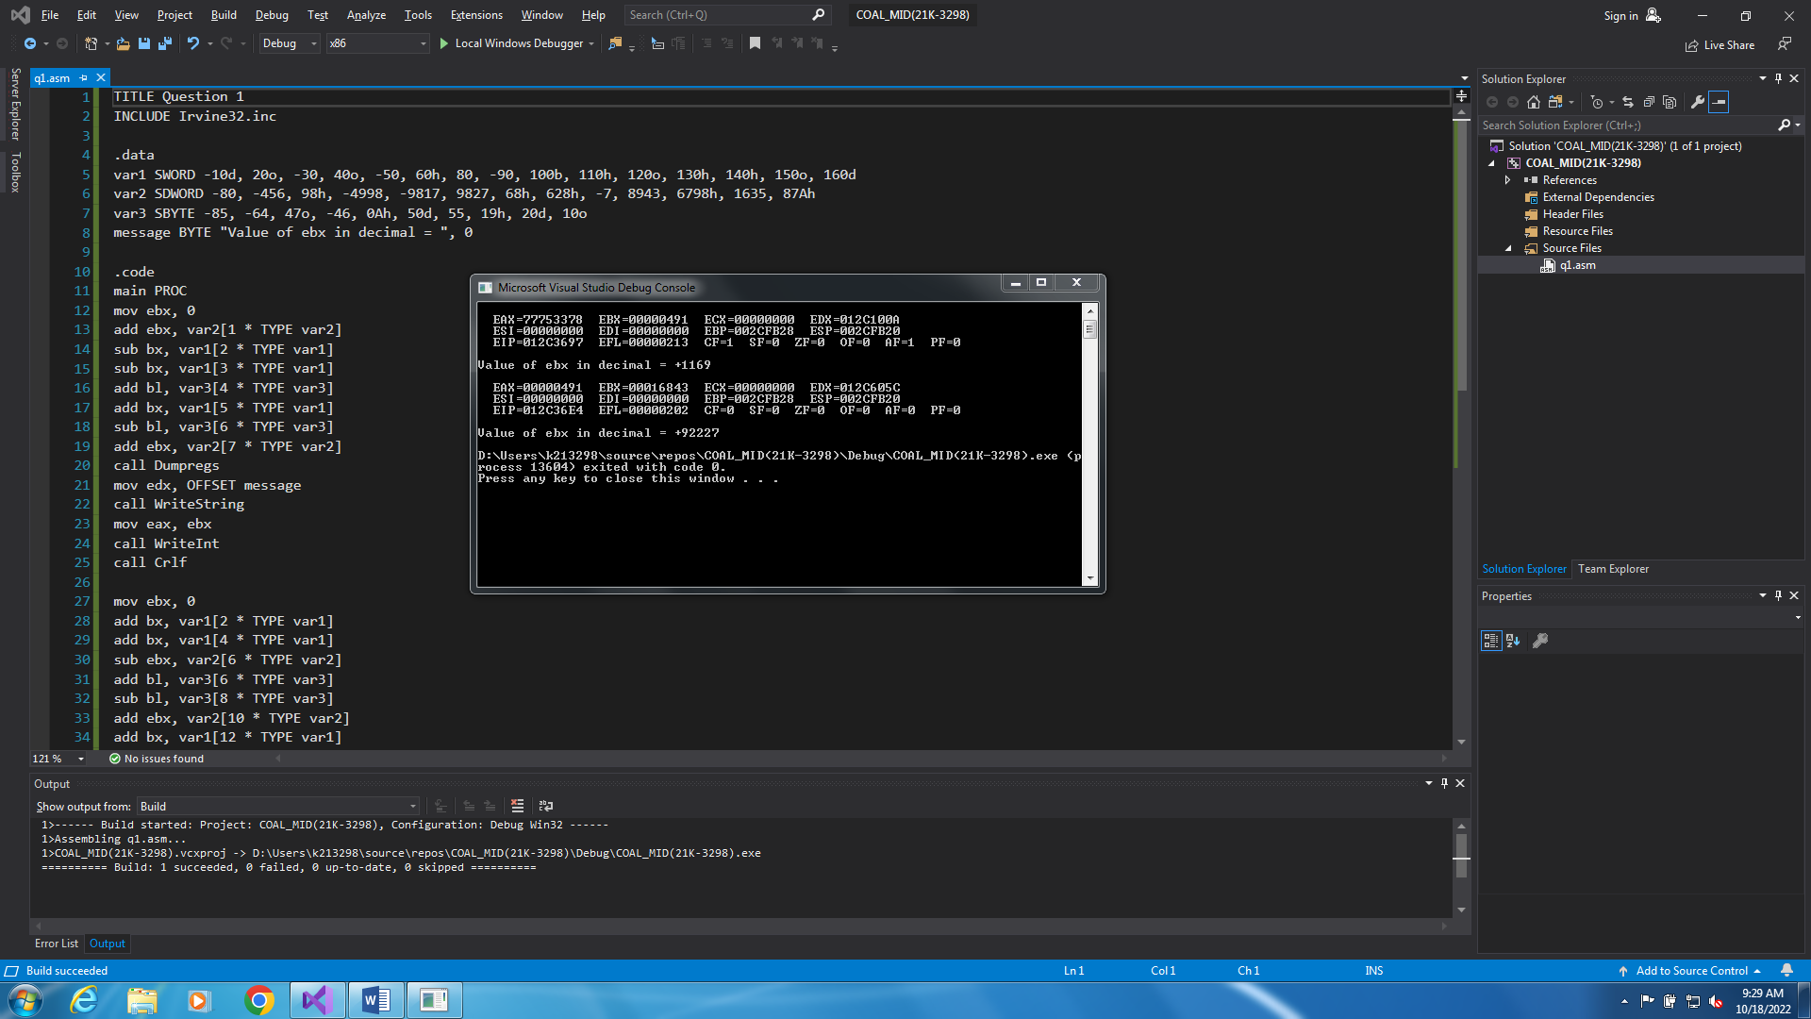

Question # 02:

TITLE Question 2
INCLUDE Irvine32.inc

.data
count = 100
array SBYTE count DUP(?)
random SWORD ?

.code
main PROC
call Randomize
call Random32
mov random, ax
mov esi, 0
mov ecx, count
L1:
movzx eax, random
call RandomRange
mov array[esi], al
add esi, TYPE array
loop L1

mov esi, 0
mov ecx, count
PRINT:
movzx eax, array[esi]
call WriteInt
mov eax, " "
call WriteChar
add esi, TYPE array
loop PRINT

call Crlf
exit
main ENDP
END main
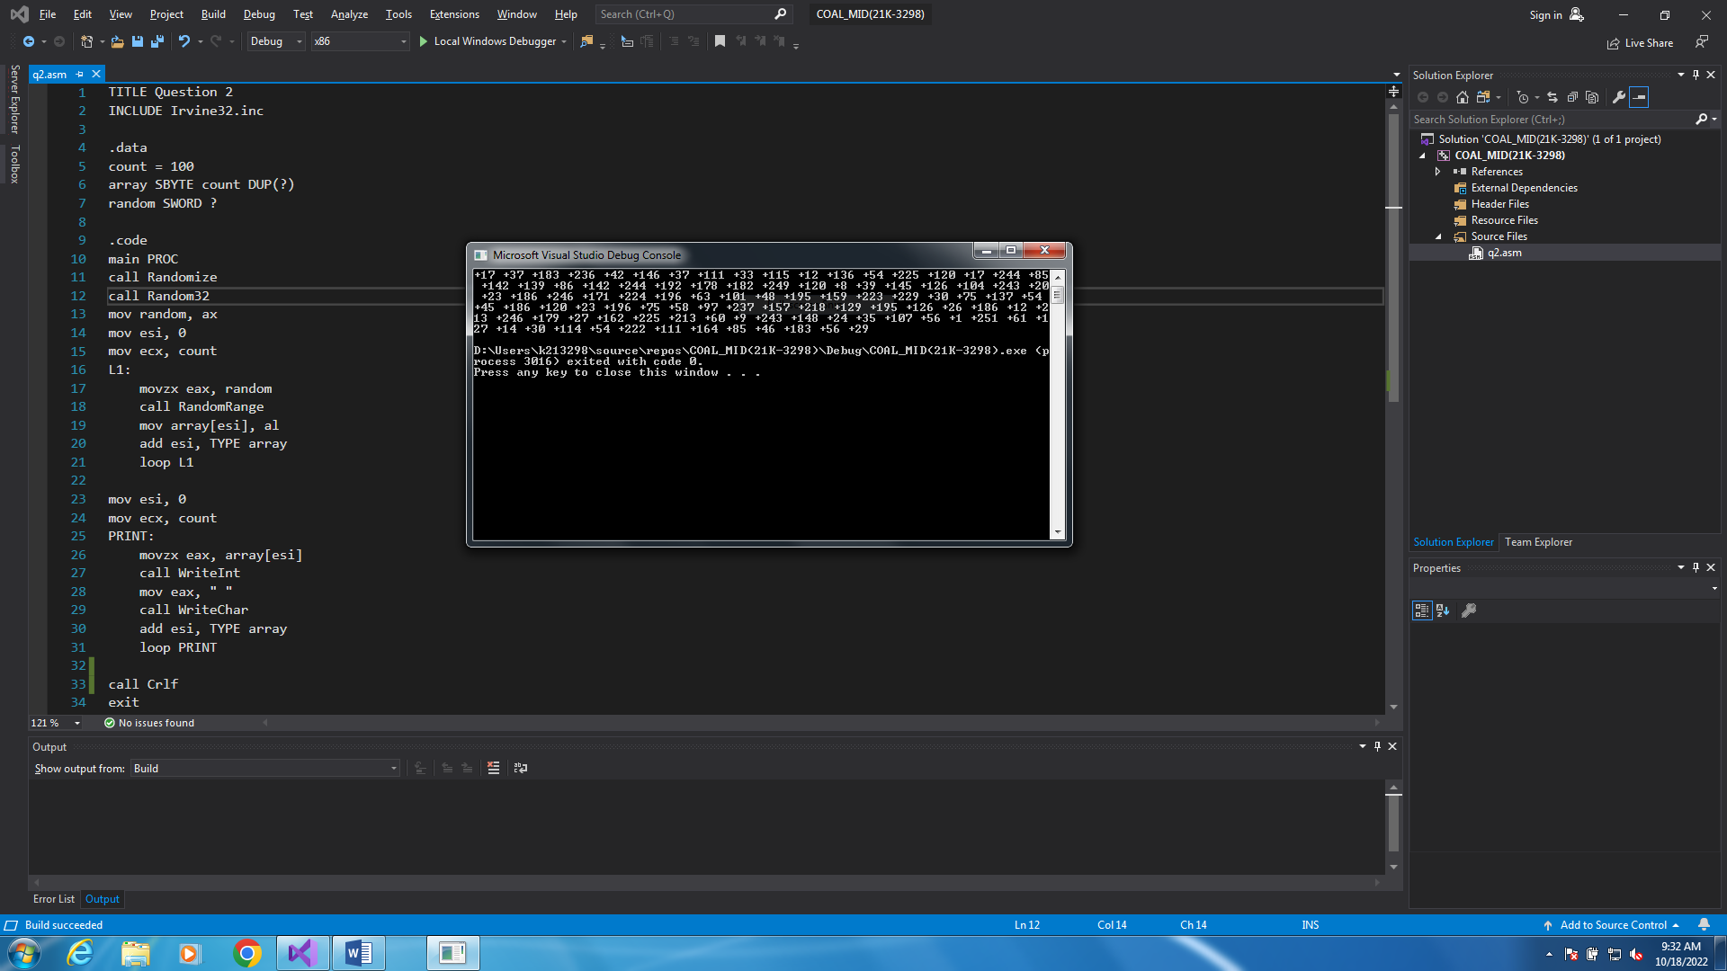

Question # 03:

TITLE Question 3
INCLUDE Irvine32.inc

.data
count = 5
row DWORD ?
column DWORD ?
character DWORD "*"
space DWORD " "
prompt1 BYTE "Enter number of rows: ", 0
prompt2 BYTE "Enter number of columns: ", 0
prompt3 BYTE "Enter character", 0

.code
main PROC

mov edx, OFFSET prompt1
call Writestring
call ReadDec
mov row, eax
mov edx, OFFSET prompt2
call WriteString
call ReadDec
mov column, eax
mov edx, OFFSET prompt3
call WriteString
call ReadChar
mov character, eax
call Crlf

mov esi, 1
mov ecx, row
L1:
push ecx
mov ecx, column
L2:
mov eax, space
call WriteChar
loop L2
pop ecx
push ecx
mov ecx, esi
L3:
mov eax, character
call WriteChar
loop L3
call Crlf
pop ecx
inc esi
dec column
loop L1

exit
main ENDP
END main
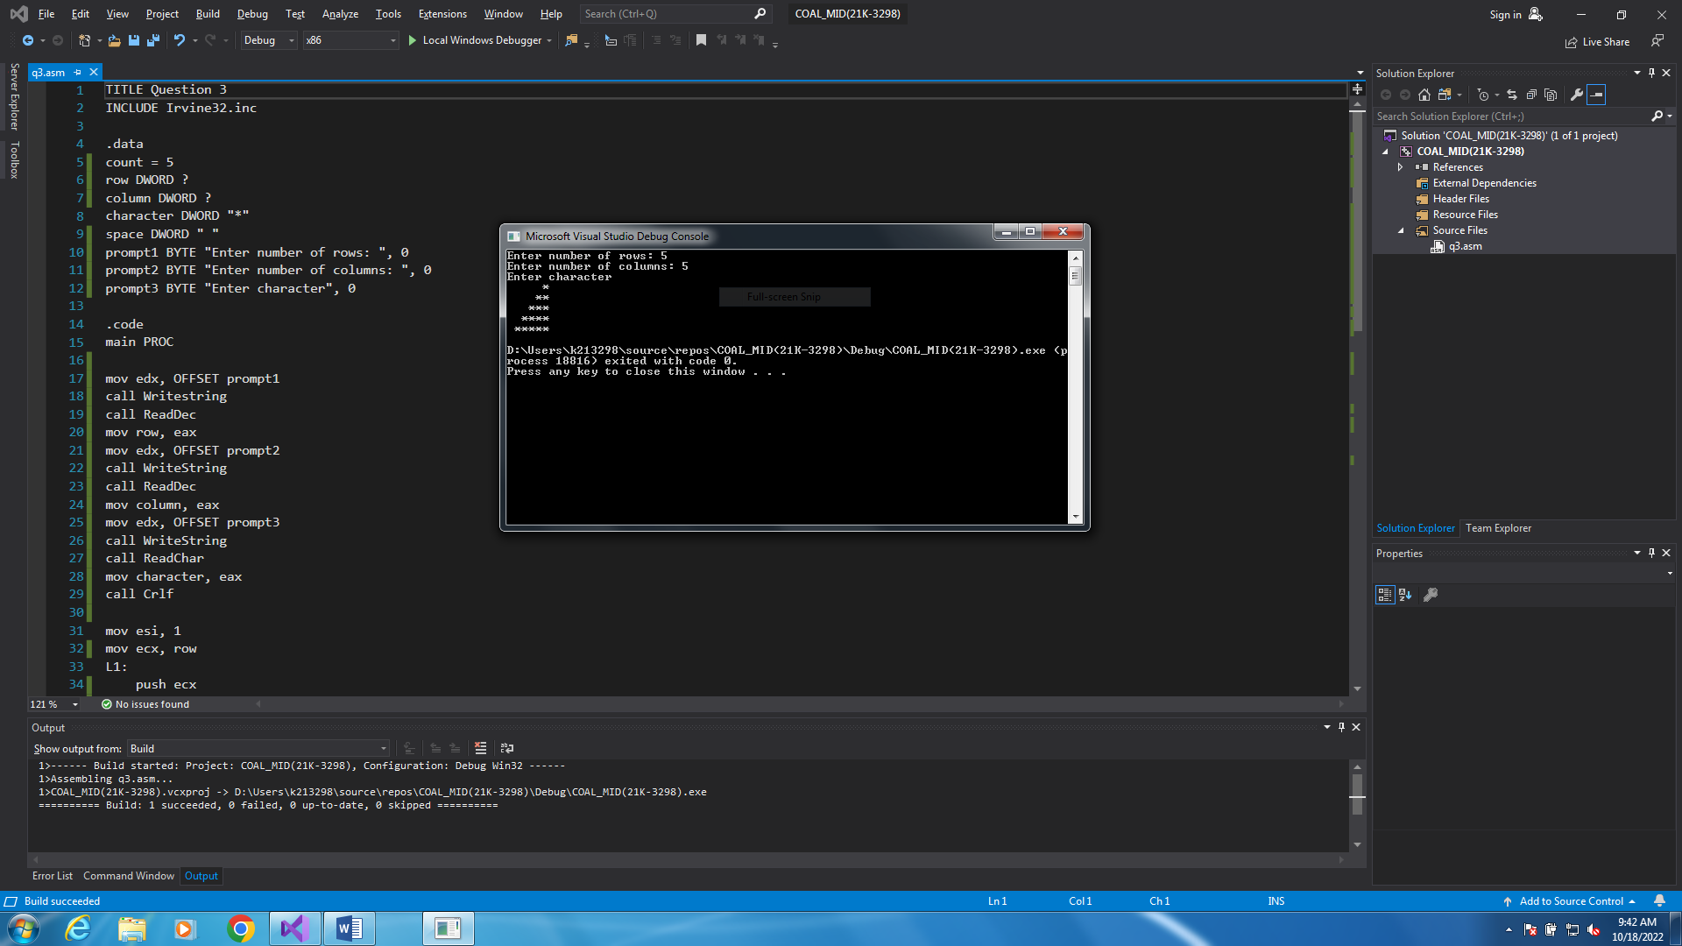

Question # 04:

TITLE Question 4
INCLUDE Irvine32.inc

.data
startValue = 857
endValue = 434

.code
main PROC
call Randomize
mov al, 09Fh
mov ah, 00h
call SetTextColor
mov eax, startValue
mov ebx, endValue
call randomNumbers
exit
main ENDP

randomNumbers PROC
mov dl, 0
mov dh, 0
call WriteDec
add dh, 1
add dl, 2
mov ecx, 18
L1:
push eax
call GotoXY
add dh, 1
add dl, 2
call RandomRange
call WriteDec
pop eax
loop L1
call GotoXY
mov eax, ebx
call WriteDec
ret
randomNumbers ENDP

END main
